Class: Final Year (Computer Science and Engineering)

Year: 2023-24 Semester: 1

Course: High Performance Computing Lab

**Practical No.10**

PRN No: 2020BTECS00112

Name: Meet Vipul Gandhi

Q1: Implement a MPI program to give an example of Deadlock.

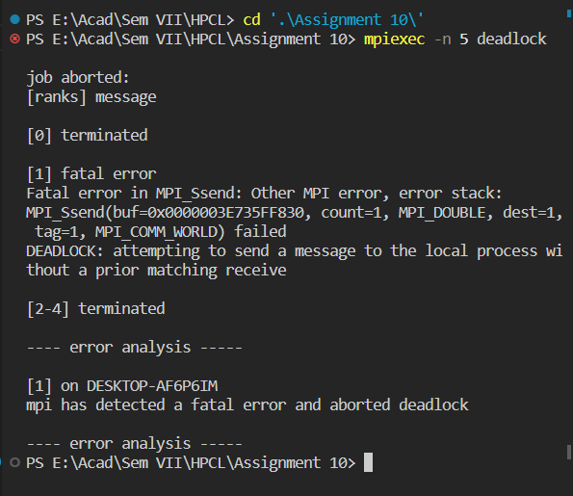

Q2. Implement blocking MPI send & receive to demonstrate Nearest neighbor exchange of data in a ring topology.

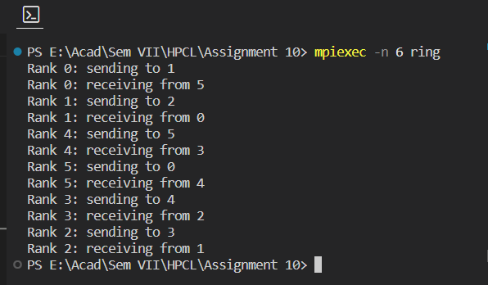

Q3. Write a MPI program to find the sum of all the elements of an array A of size n. Elements of an array can be divided into two equals groups. The first [n/2] elements are added by the first process, P0, and last [n/2] elements the by second process, P1. The two sums then are added to get the final result.

